**Adeel Mustafa**

**BIT-23F-028**

**LAB TASK 07**

**Task # 01**

Write a Python function that draws a square using asterisks (*). The side length of the square should be provided by the user.

**Code**

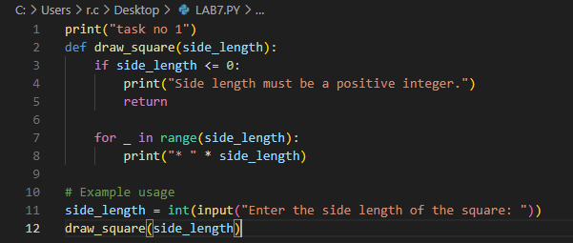

**Output:**  
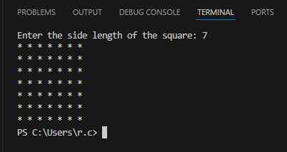

**Task # 02**

Write a Python function that takes a list of numbers as input and returns the sum of only the even numbers.

**Code:**

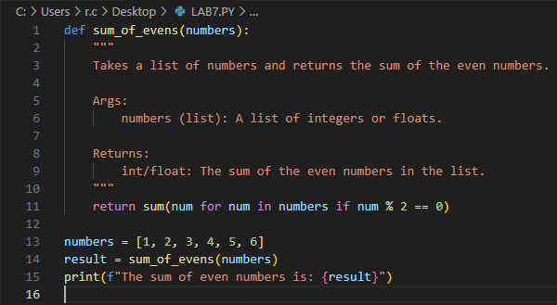

**Output:**

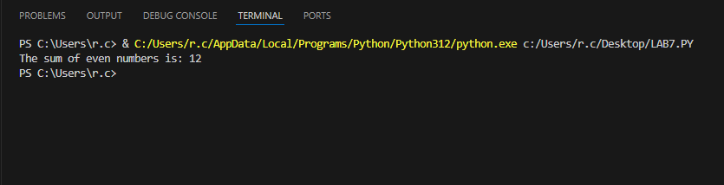

**Task # 03**

Write a Python function that takes a number as input and counts down to zero, printing each number.

**Code:**

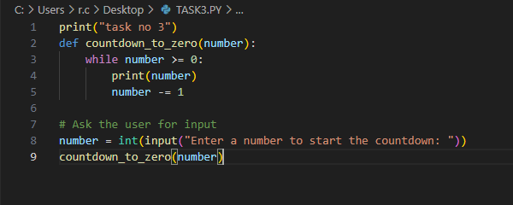

**Output:**

